**Mathematics Methods Unit 3 2019**

**Investigation 1: Roller Coaster Design**

**Name:____________________________ Mark ____ / 28**

**The mark for this section will constitute 50% of the total investigation mark. Notes will not be allowed in this section, however calculators will be allowed.**

**Time allowed 40 minutes.**

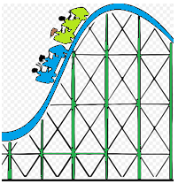**Part C**

Answer the questions below in the spaces provided.

**Question 1 [ 15 marks]**

Your first task is to design an *ascent* and *drop* for the first section of roller coaster track.

You will connect two straight stretches of track,  and , with part of a parabola , where *x* and  are measured in metres.

The slope of the *ascent* is 0.74 starting from the origin O and the slope of the *drop* is

- 1.4.

Determine the equations of the *three segments* of track indicated below for the given domains, showing all appropriate steps of logic in the space below and on the next page:

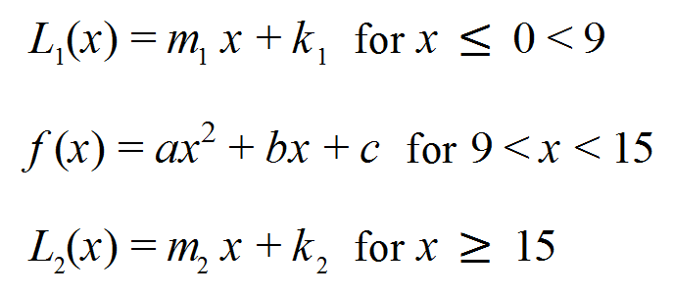

**Question 2 [ 8 marks]**

Join the same two linear functions in Question 1 with a cubic function this time, given that the top point of the curve between the X-values of 9 and 15 is the point (11,8.2).

**Question 3 [ 2,1,1,1 = 5 marks]**

**a)** State two factors that reduce the speed of the roller coaster as it goes down the track?

**b)** What force keeps the roller coaster on the track as it goes through a loop?

**c)** Under what circumstances might a negative ordinate (Y-axis) value be possible?

**d)** Where should the highest point of the track be?

**END OF VALIDATION**